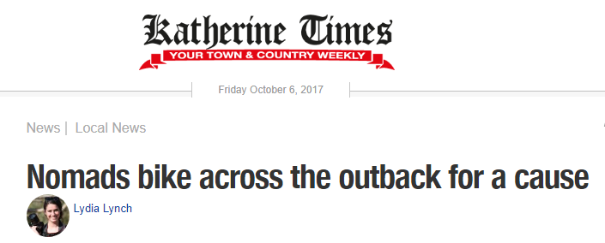
8 Aug 2017, 2:27 p.m.
BIG RIDE: Three women in their 60s are cycling across the outback.
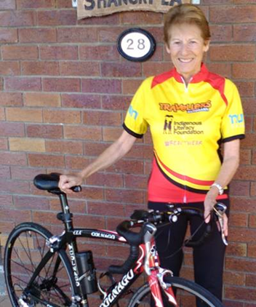
We are used to seeing grey nomads in caravans but this time they will be coming into town on bicycles.
Brenda Noonan and her team are tackling a gruelling 3000 km bike ride to raise funds for Indigenous literacy.
“On August 17 three of us "older but young at heart" ladies will commence biking from Adelaide - and will finish up in Darwin 3100 kilometres later on September 17,” Ms Noonan said.
“We are all in our 60's - but are keeping active and showing just what can be done. Our ride is called Biking for Books, as we are fund-raising for the Indigenous Literacy Foundation as well as providing books and talking to school children along the way.”
The team will be arriving in Katherine on September 14.
“It will be a testing ride with weather conditions and the remoteness tough things to deal with,” Ms Noonan said. “We will be averaging 120 kms a day with our shortest day being 75 kms and our longest 180 kms.”
“We will be starting the ride at the John McDouall Stuart Statue in Victoria Square, Adelaide at 9am on the August 17, the day I turn 64 years old,” she said. “We will finish the ride at the War Memorial in Darwin on September 17. We have had special bike shirts made in the colours of the aboriginal flag and our "off" bike shirts are a variation on this theme too.”
Follow the journey on Facebook or their website.

